Sight for Blind with Panic Button

Lakshay Nanda 1

VIT, Vellore [lakshaynanda@ieee.org](mailto:lakshaynanda@ieee.org)

Keshika Tank 2

VIT, Vellore [keshika.tank2016@vitstudent.ac.in](mailto:keshika.tank2016@vitstudent.ac.in)

Prof. Santhi V 3

VIT, Vellore

[vsanthi@vit.ac.in](mailto:vsanthi@vit.ac.in)

***Abstract*— Visual impairment as an impediment has been normally happening in each general public in the history. Amid the vast majority of the history, outwardly debilitated individuals (and every single crippled individuals besides), have been viewed as a social weight and if not dealt with by their families, most would die in the cruel condition. Daze children would be deserted, and dazzle grown-ups would regularly finish up as homeless people. The capacity to peruse and compose, which the visually impaired network recaptured with Braille's development, was simply the initial step to training, liberation, and independence of visually impaired people. This venture will comparably improve lives of outwardly weakened by giving them an approach to stroll around openly and have better authority over things.**

***Keywords—Raspberry Pi, Tensorflow, GSM, Wifi Module, Panic Button***

1. INTRODUCTION

This paper surveys the cutting edge in the field of assistive gadgets for sight-debilitated individuals. It focuses specifically on different frameworks that utilization picture and video preparing for changing over visual information into an other rendering methodology that will be valuable for a visually impaired client. Such substitute modalities can be sound-related, haptic, or a mix of both. There is along these lines the requirement for methodology change, from the visual methodology to another; this is the place picture and video preparing assumes an essential job. The conceivable exchange tangible channels are analyzed with the motivation behind utilizing them to show visual data to thoroughly daze people. A refinement is made by the last yield channel. This paper determines that Haptic encoding is the frequently utilized by methods for either material or consolidated material/sensation encoding of the visual information. Sound-related encoding may prompt minimal effort gadgets, yet there is have to deal with high data misfortune brought about while changing visual information to sound-related one. Notwithstanding a higher specialized unpredictability, sound/haptic encoding has the benefit of making utilization of all accessible client's tactile channels. In this paper 2D pictures were coded by tone blasts speaking to specks comparing to picture information. Picture handling was insignificant. The vertical area of each spot was spoken to by the tone recurrence, while the even position was passed on by the proportion of sound plentifulness.

1. LITERATURE REVIEW
2. *Character recognition and detection system for visually impaired people*

This paper portrays an approach to manage concentrate and see content from scene pictures sufficiently using PC vision development and to change over apparent substance into talk so it will in general be joined with gear to make Electronic travel help for ostensibly weakened people in future. Perceiving content from scene picture is progressively troublesome when appeared differently in relation to that from printed chronicles. Bundles of research has been done on recognizing scene substance to beat certain challenges like perspective mutilation, perspective extent, content measurement, etc. Speed, unusualness, cost and accuracy are basic parameters must be considered while arranging such structures. PC vision is one of the creating developments that can be used to help ostensibly ruined people for course (both indoor and outside), getting to printed material, and etc.

1. *Recognition of Object for blind people based on feature extraction*

This paper gives a diagram of different visual substitution frameworks created in the ongoing years. It points additionally to present a proposed technique that reestablishes a focal capacity of the visual framework which is the distinguishing proof of encompassing items. This technique depends on video examination and elucidation. In this manner, the commitment of this paper is to display a visual substitution framework dependent on assessing quick and hearty calculations to perceive and find protests in pictures.

1. *A multifunctional Reading assistant for visually impaired*

This paper tends to the significance of the innovation where an archive can be checked and the content data bolstered into the PC can be broke down for content parts. These perceived segments are then vocally integrated. This paper goes for stretching out this innovation to portable use, since up until now, the innovation is constrained to families and static use. The modules utilized for this present paper's model incorporate human-machine interface, Windows API, Camera API, Image handling module, TTS motor and application portion. The article acknowledgment works utilizing the accompanying components: Gradient square characterization, design discovery and confirmation,

division and binarization, OCR for content acknowledgment, post OCR approval, information gestion. The paper likewise covers the different existing acknowledgment strategies, including content peruser for visually impaired individuals that utilizes the K-NFB peruser, normal scene content perusing calculations, utilized for content acknowledgment for tag ID or programmed sign interpretation for outsiders. It likewise completes a definite report on programmed content perusing, expressing that their model makes utilized of various finished areas for various literary substance (utilizing edge thickness measures). For content division and acknowledgment, they have utilized content extraction methods, in light of on shading pictures or luminance. This is trailed by an examination of item acknowledgment utilizing the modules referenced above and an indisputable provide details regarding results, that were prevalently positive.

1. *Fuzzy relative position between objects in image processing: a morphological approach*

In order to conform to the uncertainty of spatial relative position musings, this paper proposes another significance of the relative position between two things in a delicate set system. This definition depends upon a morphological and delicate model arranging strategy, and includes emerging an article from a fluffy scene tending to the component of fulfillment of a directional relationship to a reference object. It has unimaginable formal properties, it is adaptable, it fits the motivation, and it will as a rule be utilized for collaborator point of reference insistence under imprecision.

1. *Blind navigation system using image processing and embedded system*

This paper for the most part centered around giving visually impaired people the capacity to get to the data given by street signs. It comprises of a programmed street sign acknowledgment framework. This framework additionally gives the information that us required for notice and directing the individual, to make his/her voyage less demanding. This framework depends on human arrangement of acknowledgment. It utilizes a LPC2138 microcontroller with a glimmer memory of around 256 kB, a ultrasonic sensor which utilizes the idea of the Doppler Effect. A GSM module is utilized that works at 1800 MHz The calculation essentially changes over the pictures to grayscale and after that identifies the SURF highlights and stores it in its database. It does likewise to coordinate pictures with the database aside from that it coordinates the highlights in the wake of separating at that point. This technique provides some confidence to the visually impaired individuals. In any case, it doesn't give the exact area to the client utilizing the GPS. It is additionally a marginally costly arrangement and should be made less expensive so as to be adaptable. This paper emphasized on the point of making something but not affordable and far too complex for a visually impaired person to use. The technology is fine and would be helpful for the visually impaired but is not helping the person in making life easier.

1. *Image recognition for visually impaired people by sound*

A few endeavors have bene made to utilize picture acknowledgment to help the outwardly disabled. One such endeavor included edge identification in the information picture, in light of the acquired edge data, sound is created. the sound is additionally examined by utilizing measurable properties like mean from wavelet coefficients. the different factual properties were found to vary dependent on the term of sound which thusly relied upon the length of the picture. these factual properties were utilized to arrange the pictures in different classifications, and the class of the picture was recorded in human voice utilizing receiver. The suitable chronicle was said to be played dependent on the scope of the measurable properties.

1. *Emergency Panic Button*

Google's Android platform for cell phones has immediately formed into a genuine open source elective. We investigated the Android Operating System (OS) and programming improvement condition and assessed a few of its capacities by building a working application. This application gathered speed and area data from the Global Positioning System (GPS) beneficiary, utilized the Google Maps Application Programming Interface (API) to decide the area of adjacent clinics, and offers message to emergency clinics and relatives, if an individual need an assistance. The stage demonstrated equipped for supporting a merging of various administrations, and we accept such cell phones have expansive appropriateness to open wellbeing issues.

1. *Computer Vision Technologies for visually impaired: An overview*

This paper underscores to think about the distinctive methodology or procedures used to help the visually impaired or vision debilitated individuals. It is a relative overview which brings up the preferences and weaknesses of every system alongside some critical focuses. It portrays the different strategies from crude dimension to comparable/high experienced, making it helpful for specialists for further investigation.

1. *Text Reader for Blind : Text to Speech*

Human asset and the PC framework give the ideal worldview of an inconvenience shooter. Such frameworks should be easy to use, precise, and performing multiple tasks as they are required by each segment of individuals. Be that as it may, with regards to outwardly hindered individuals they (the product's/frameworks) represent a lot of battle and trouble and the total use of the offices is hampered while utilizing the visual interface. This can be unraveled by utilizing the conference capacity. Remembering this the product will probably peruse the content present in the screen, website page, report or a content entered in a content box utilizing Free TTS content to-discourse Synthesizer. The content will be changed over into a discourse by breaking down and preparing the content utilizing Natural Language Processing (NLP) and afterward utilizing Digital Signal Processing (DSP) innovation to

change over this handled content into combined discourse portrayal of the content. Through the discourse or voice outwardly disabled individuals can almost certainly hear huge volume of content simpler. Other than simply the content to discourse office the product will have an office to remove the content into a sound document like *.mp3,

*.wav and so forth. It will be a productive manner by which dazzle individuals can likewise connect with the PC and use the offices of the PC.

1. PROPOSED SYSTEM

Our major focus in this paper is to help the visually impaired in walking as well as help them in case of emergency, so for that we are proposing a model in which there will be a blind person’s stick to which there will be an ultrasonic sensor attached and a camera module for raspberry pi.

The ultrasonic sensor will determine the presence of something in front of the stick and the camera module will be actively taking pictures of the object in front. That image will be converted to text using tensorflow and we will be employing a module that will convert text to audio. And the visually impaired person will be able to hear the audio using headphones that he/she will be wearing.

1. ARCHITECTURE

There are three main aspects to our framework. The first part begins with a basic *Object Recognition System* that is available online for free, containing thousands of images and objects trained one by one. They cover a vast array of objects that can come in contact with the stick. The second part is *cross checking the object recognized with the database* our stick has. There are two ways to do this. The cheaper alternative is to save all the data within the stick. The memory can range up to 16 - 32 GB and would store all the information locally. The other alternative would be to have wireless connectivity embedded in the stick. This option has more risk as any contact to water or regular wear and tear can damage the stick. We also need to take care of the fact that the outer covering of our stick must be light yet durable to withstand any sudden jerks or wear and tear. The camera lens must be made up of gorilla glass so that even if a blind person taps it on a foreign object, it doesn’t crack. The third part is using an *ordinary text to speech converter and provide the audio translation of the recognized object.* There are further two ways to do this. We can either add a speaker to the tail of our stick and publicly announce or declare what object it is or send information to a pair of headphones that can be worn by the blind person.

**Integrating our Object Recognition Software with the Hardware:** The block diagram of safety stick for blind people contains a camera module, Raspberry Pi, Tensorflow, Text to Speech Module and Headphones through which helps visually impaired to listen about what is present in front of them.

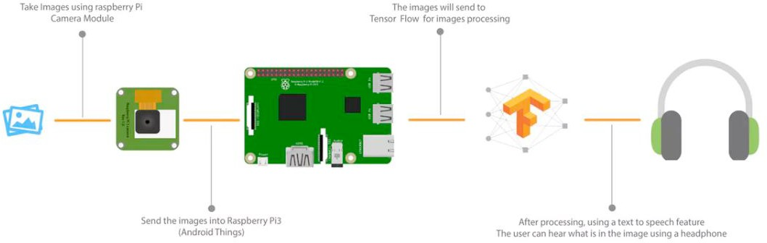

Fig 1. Proposed Model Design

1. MODULES
2. *Object/Obstacle Detection*

The main intent of detection of obstacle is to determine the nearness of obstacles before the clients, while the deterrent cautioning speaks to and sends this data to the clients.

This can be done using many methods:

* 1. ET Sensor
  2. Top Hat Sensor
  3. Touch Sensor
  4. Lever Sensor

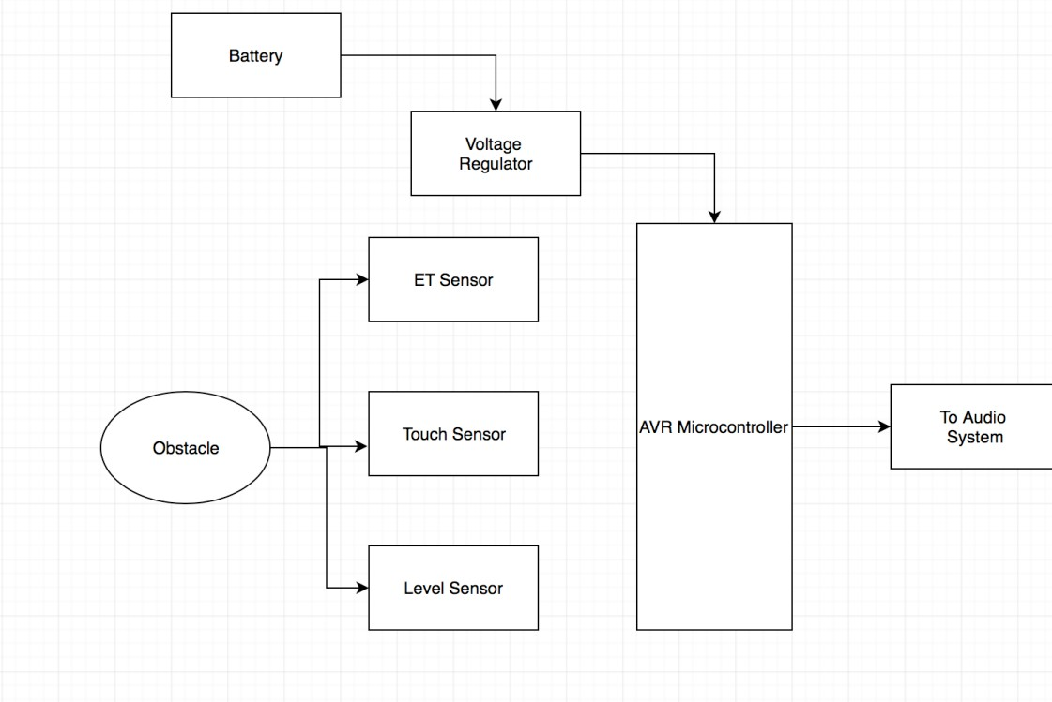

Fig 2. Obstacle Detection

1. *Image Recognition*

Picture affirmation, with respect to machine vision, is the limit of programming to perceive objects, places, people, making and exercises in pictures. PCs can use machine vision propels in blend with a camera and man-made mental ability programming to achieve picture affirmation. Picture affirmation is used to play out a broad number of machine- based visual errands, for instance, denoting the substance of pictures with meta-marks, performing picture content chase and controlling self-decision robots, self-driving automobiles and disaster avoiding systems.

While human and animal cerebrums see protests easily, PCs experience issues with the task. Programming for picture affirmation requires significant machine learning. Execution is best on convolutional neural net processors as the specific errand by and large requires immense proportions of force for its register concentrated nature. Picture affirmation counts can work by usage of close 3D models, appearances from changed focuses using edge acknowledgment or by segments. Picture acknowledgment calculations are

frequently prepared on a huge number of pre-named pictures with guided PC learning.

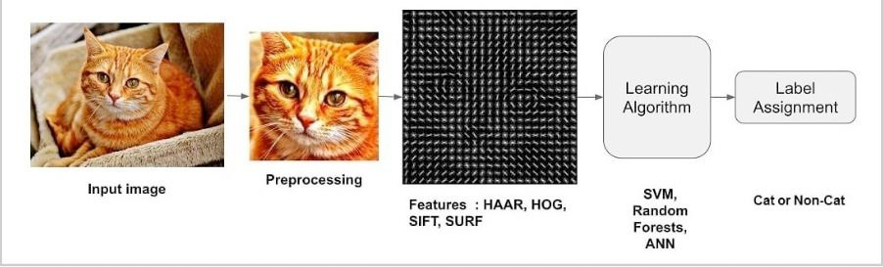

Fig 3. Image Recognition

In this type of image/object recognition the system need not learn or rather it utilizes lazy learning of just storing some image descriptors in a search indexing data structure like the Kd-tree or Locality sensitive hashing (LSH). This has three stages:

* 1. Key point detection
  2. Descriptor extraction
  3. Matching and verification

1. *Object Detection*

Object Detection is looking for real-world item instances like bike, flowers, car, TV and humans in motion-less images or Videos. This helps in the localization, detection and recognition of various objects within an image itself which caters to us with a better understanding of an image as a whole.

Object Detection can be done via multiple ways:

* 1. Feature-Based Object Detection
  2. Viola Jones Object Detection
  3. SVM Classifications with HOG Features
  4. Deep Learning Object Detection

In this project, we’ll be using Deep Learning Object Detection as Tensor flow uses Deep Learning for computation.

Tensor flow is Google’s Open Source Machine Learning Framework for dataflow programming across a range of tasks. Nodes represent mathematical operations, while the graph edges represent the multi-dimensional data arrays (tensors) communicated between them.

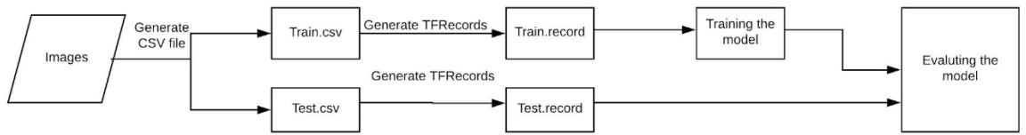

Fig 4. Object detection

The smart stick on detecting any obstacle, will click a picture of the same. The identified image will then be used to identify the object using Tensor Flow. the image of the object will be compared to various objects in the database and on finding a match, the name of the object will be sent to the next module to convert the name into audio.

1. *Converting into Audio*

There are plenty of open source codes and API’s for text to speech conversation. Once our SSD model identifies which object is there, we just need to convert that name into a string and pass that string as a parameter to the TTS function (Text-to-Speech).

Our brains influence vision to appear to be simple. It doesn't require much exertion for us to tell distinction between a lion and a tiger, read a sign, or perceive a human's face. In any case, these are difficult issues to explain with a PC: they just appear to be simple in light of the fact that our minds are extraordinarily great at understanding pictures. In the previous couple of years, the field of machine learning has gained gigantic ground on tending to these troublesome issues. Specifically, we've discovered that a sort of model called a profound Convolutional Neural Network that cancan accomplish sensible execution on hard visual acknowledgment undertakings - coordinating or surpassing human execution in a few areas.

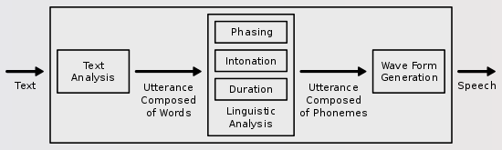

Fig 5. Text to Speech

Using the aforementioned, an image recognition algorithm can be made. Further the images can be named by using the dataset of Tensor Flow. Given that we have everything on the computer, text to speech algorithm can be used to convert the data to audio. This combination of image recognition and text to speech translator can give us a device that will tell the visually impaired what they are looking at. This way they will have a better sense of surroundings.

1. *Panic Button*

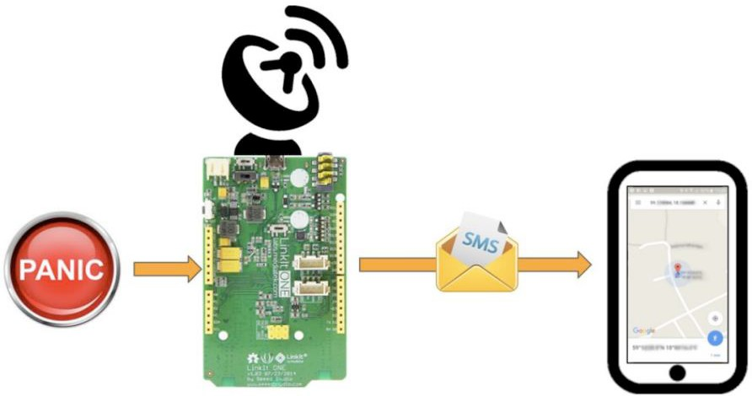In this module we incorporate safety feature for the blind. This module uses GPS and GSM module to implement the functionality. When the visually impaired person clicks on the panic button when he thinks he is in some emergency, then the GPS module collects the current location of the blind person in the form of geo-coordinates (i.e. latitude and longitude) and this information is added along with an emergency message. This message is then sent by the GSM module to the guardians or relatives of the blind person so that they can come to his location as soon as possible.

1. CONCLUSION

The Sight for blind is a product prototype to aid the blind people in their day to day lives. The product uses concept of image processing using Tensor Flow and text to audio conversion so that the blind knows what the object detected is. Further developments that can be done in the product are – firstly the range of objects that can be detected are restricted to knowledge of just one API, some objects that look similar will need personalized training on specific data so that they can be differentiated. Second, the hearing of audio will not be useful for a person who is both blind and deaf. As a solution we can send vibrations that can alert the person of objects in front of him/her.

REFERENCES

1. Sanjana, B., and J. Rejina Parvin. "Voice assisted text reading system for visually impaired persons using TTS method." IOSR Journal of VLSI and Signal Processing 6, no. 3, 2016, pp. 15-23.
2. Gladence, L. Mary, Shubham Melvin Felix, and Aatisha Cyrill. "Text Reader for Blind: Text-To-Speech." International Journal of Pure and Applied Mathematics 117, no. 21, 2017, pp. 119-125.
3. Fathy, Mahmood, and Mohammed Yakoob Siyal. "An image detection technique based on morphological edge detection and background differencing for real-time traffic analysis." Pattern Recognition Letters 16, no. 12, 1995, pp. 1321-1330.
4. Shrivakshan, G. T., and C. Chandrasekar. "A comparison of various edge detection techniques used in image processing." International Journal of Computer Science Issues (IJCSI) 9, no. 5, 2012, pp. 269.
5. Menard, Raymond J., and Curtis E. Quady. "Emergency response information distribution." U.S. Patent 6,563,910, issued May 13, 2003.
6. Krishnan, K. Gopala, C. M. Porkodi, and K. Kanimozhi. "Image recognition for visually impaired people by sound." In 2013 International Conference on Communication and Signal Processing, pp. 943-946. IEEE, 2013.
7. Jabnoun, Hanen, Faouzi Benzarti, and Hamid Amiri. "Object recognition for blind people based on features extraction." In International Image Processing, Applications and Systems Conference, pp. 1-6. IEEE, 2014.
8. Filipe, Vítor, Filipe Fernandes, Hugo Fernandes, António Sousa, Hugo Paredes, and João Barroso. "Blind navigation support system based on Microsoft Kinect." Procedia Computer Science 14, 2012, pp. 94-101.
9. Panchal, Akhilesh A., Shrugal Varde, and M. S. Panse. "Character detection and recognition system for visually impaired people." In 2016 IEEE International Conference on Recent Trends in Electronics, Information & Communication Technology (RTEICT), pp. 1492-1496. IEEE, 2016.
10. Pun, Thierry, Patrick Roth, Guido Bologna, Konstantinos Moustakas, and Dimitrios Tzovaras. "Image and video processing for visually handicapped people." Journal on Image and Video Processing 2007, no. 5, 2007, pp. 4.
11. Mancas-Thillou, Céline, Silvio Ferreira, Jonathan Demeyer, Christophe Minetti, and Bernard Gosselin. "A multifunctional reading assistant for the visually impaired." Journal on Image and Video Processing 2007, no. 3, 2007, pp. 5.
12. Hoang, Van-Nam, Thanh-Huong Nguyen, Thi-Lan Le, Thanh-Hai Tran, Tan-Phu Vuong, and Nicolas Vuillerme. "Obstacle detection and warning system for visually impaired people based on electrode matrix and mobile Kinect." Vietnam Journal of Computer Science 4, no. 2, 2017, pp. 71-83.
13. Sanjana, B., and J. Rejina Parvin. "Voice assisted text reading system for visually impaired persons using TTS method." IOSR Journal of VLSI and Signal Processing 6, no. 3, 2016, pp. 15-23.
14. Shrivakshan, G. T., and C. Chandrasekar. "A comparison of various edge detection techniques used in image processing." International Journal of Computer Science Issues (IJCSI) 9, no. 5, 2012, pp. 269.
15. Yasin, A. Sadat Mohammed, M. Majharul Haque, S. Binte Anwar, and

M. Shakil Ahamed Shohag. "Computer vision techniques for supporting blind or vision impaired people: An overview." International Journal of Scientific Research Engineering and Technology (IJSRET) 2, 2013, pp. 498-503.

1. Bloch, Isabelle. "Fuzzy relative position between objects in image processing: a morphological approach." IEEE transactions on pattern analysis and machine intelligence 21, no. 7, 1999, pp. 657-664.